**Apache Hive Assignment: 6**

1. **Consider the data set and create a managed table named as “Temperature” with following fields**

**Date as string, city as string, mytemp as array of double and delimiter as “tab” and collections**

**Items as “,”**

**Dataset_Temperature**  
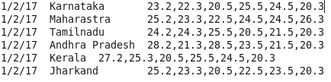

**And finally retrieve the temperature table.**

1. 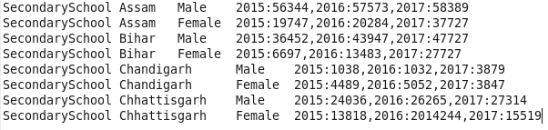

**Consider the dataset and create a managed table named as “MySchools” with following fields**

**Schooltype as string, state as string, gender as string, total_map as <int,int> , delimiter as “tab”**

**Collection items “,” map keys “:”**

**And finally retrieve the MySchools table.**

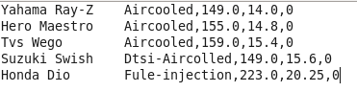

1. **Consider the data set and create a managed table named as “MyBikes” with following fields**

**Name as string, Bikefeatures as struct which contains fields as enginetype as string, cc as float**

**Power as float, gears as int and delimiter as “tab”, collection items as”,”**

**And finally retrieve the “MyBikes” table.**